April 2019



**Conference Department: Essentials for Business Development**

**Table of contents**

1. Login details 2

2. Address 3

3. Outlook Basics 3

4. Staff weekend 5

5. Time Management System – TMS 5

6. Overview of ongoing conferences 5

7. Picking up the telephone 5

8. Making calls 6

9. Tourplan 6

10. E-Zine/Mailchimp/Subscription Form 8

11. Surveymonkey 12

12. ICCA Database 13

13. Databases that need to be updated (Venue folder, Mail Database, Irish Associations) 15

14. Irelandscontentpool 16

15. Sugar CRM 16

16. Wix - Websites 19

17. SEO and Google Analytics 20

18. Bid production 25

19. General info 26

20. Conference Glossary 27

**Conference Department: Essentials**

**A neat summary for beginners.**

Starting as an intern in the conference department, the following information will get you started and is something for you to come back to whenever you need. Please also feel free to expand this first draft of a guide with any other helpful input that comes to your mind.

# Login details

**Computer and Tourplan**

Username: Conferencestaff6

Password: Abbey4$Tours

**Google Account for Google Analytics:**

Name: Abbey Conference

Username: conferencestaff6@gmail.com

Password: Abbeyconferencestaff6

**Mailchimp for E-zines:**

mailchimp.com

Username: NicoRol

Password: AbbeyConference20!8

**Wix - Websites**

www.wix.com

Username – greg@abbey.ie

Password – abbeyconference

**Twitter**

www.twitter.com/abbeyconference

Username - @abbeyconference

Password – twitterabbeyconference

**Instagram**

www.instagram.com/abbey_conference

Username - abbey_conference

Password – instagramabbeyconference

**Ireland’s Content Pool – Images for Commercial use**

www.irelandscontentpool.com

Username – gregc@abbey.ie

Password – abbeyconference

**ICCA Database**

www.iccaworld.org

Username: gregc@abbey.ie

Password: @Abbeyconf1

**Sugar CRM**

https://crm.abbey.ie/

Username**:** CEBD

Password: S4Xv74

**Surveymokey**  
https://www.surveymonkey.com/user/sign-in/?ut_source=megamenu

Username: abbey_tours

Password: conference

**EventsAir**

Username: conf4

Password: Abbey4$Tours

# Address

City Gate

22 Bridge Street Lower

Dublin 8

Phone: +353 (0) 1 648 6130 (Conference Department)

Phone: +353 (0) 1 648 6100 (Reception)

# Outlook Basics

Upon opening outlook you are in your **personal inbox**, which you can structure later on (create different folders/subfolders)

Further down on the left you will find “**Public Folders**”. These folders are available for the whole company.

Click on the Triangle 🡪 all public folders 🡪 Conference & Corporate

You will probably need the folders “Conference Confirmed” and “Conference Quotes”

Right click on the folders you need and select “add to favorites”, select options and make sure you include all the subfolders.

If you send emails add them to the public folders, your favorites will be updated automatically.

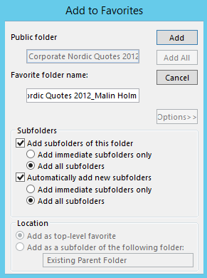

**Sending emails**

“From”: You can change the email address you use to send an email from, but you will not need that function

”CC”: include you managers email address to keep him up-to-date

“BCC”: Add as many recipients as you want (they will just see their own mail address and think it was addressed only to them)

”Signature”: Make sure to insert the conference signature by clicking on “Signature”

**Add a signature**: Click on new email, find “signature” in the “Message” tab, click on “Signatures…”, “New”. Your signature could look somewhat like the following example:

“First Name” “Last Name”

“Name of the conference” 2018 Conference Secretariat

E: [“officialconferenceemailaddress”@abbey.ie](mailto:)

W: “Website URL”

T: +353 1 648 6 XXX (your extension)

Abbey Conference & Events Logo

Attach files: Copy the file, click into the email body and insert, the file will be attached automatically

Add a Hyperlink: Write here or s.th. else, highlight the text, click right and select “Hyperlink”. Then select the location of the file or the web address you want the link to lead you to.

**Inboxes**

You will be assigned to take care of two or three inboxes. The inboxes need to be checked **constantly** and as first thing in the morning. Always try to answer an email in less than two working days. We use a colour code to flag emails for specific people:

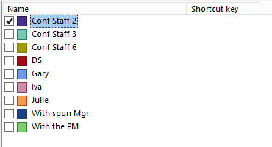

Please always tag the emails in the according colour so that other colleagues working in the inboxes see which emails you are working on. If an email has to do with sponsorship, tag it for Emma Power (With spon Mgr), forward the email to her and leave it in the inbox as a reminder. The same applies to emails for the PM. If you need help, you can always ask Julie and the other colleagues.

Remember to send an email (which is not in your personal inbox) from the conference email address, not your conferencestaff address. Also add a signature. After answering the email, you can file it into the respective folder (e.g. delegates, speaker…).

# Staff weekend

Open the internet explorer, the intranet comes up (that does not work with chrome). On the left hand side you can see a menu, under “Forms” you can find “Staff weekend”, fill out the form. Once approved make sure to take the days off.

# Time Management System – TMS

Open the internet explorer (not google chrome) and type in “TMS”, the Employee Login window comes up. Login and click on “Absence profile”, click on the day you want to take off, you will see the words “Book Absence” pop up in the upper right hand corner. Upon clicking on it, you can e.g. choose whether you only want to take the first or the second half of the day off or the full day.  
The Dashboard shows you how many holidays you have left (“Entitlements”).

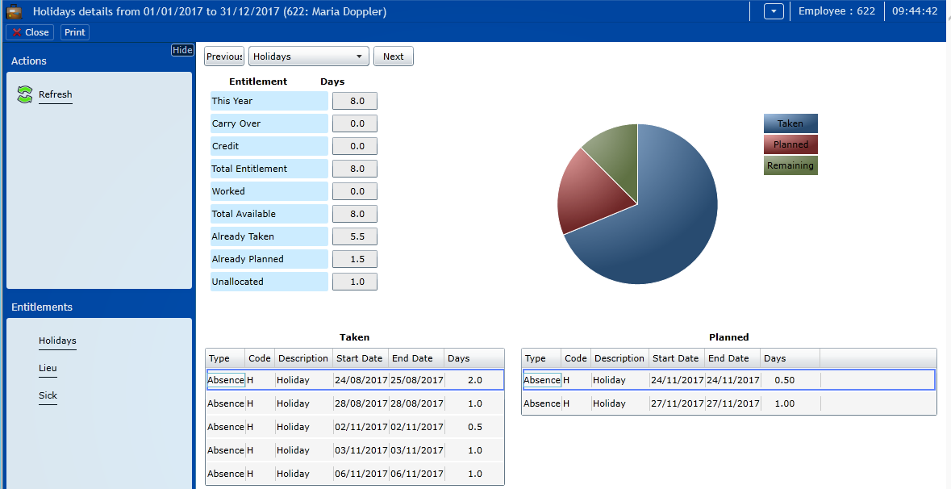

# Overview of ongoing conferences

If you get calls for conferences you can check in the following document who is responsible and other important details.

Document: Upcoming Conferences & Events

N:\Conference & Events\Statistic Reports\Conference & Events confirmed

# Picking up the telephone

Another essential task. Not only when your telephone is ringing, but also when someone else does not pick his or her phone up.

“Abbey Conferences, X speaking” would be the typical opening to a telephone call. Always ask for the **caller’s identity** and in regards to **which conference** she/he is calling for before you are transferring a call to your colleagues/the project manager of the conference. Also, see first if you could help the caller before transferring.

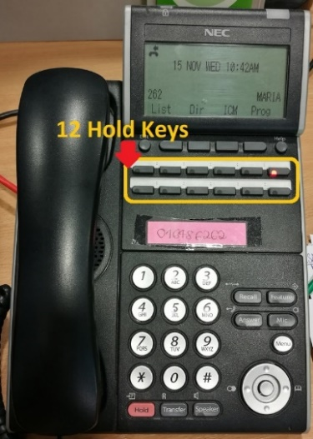

Note: If it is an internal call, the name of the caller will appear on the display otherwise you will just see the telephone number displayed.

If you need to put the caller on hold, you can use any of the 12 hold keys. To go back to the caller, press the same key again.

While the caller is on hold, you can make an internal call to see if the person they want to speak to is available. They will then have the caller on their respective hold key as well and you just have to tell them which park the caller is on.

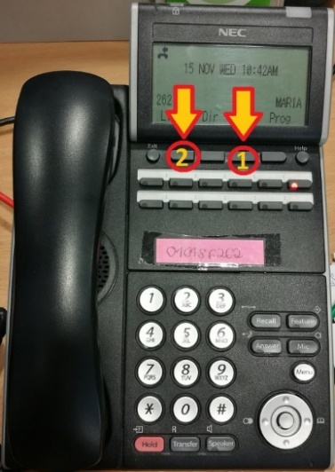   
For the extensions of your colleagues, print the **phone directory** and leave it on your desk. You will find it on the intranet. The menu at the top of the page has an item called “Phone Directories”, by clicking on it you will find the regularly updated excel file “**Abbey Tours Dublin – Phone Directory and Seating Plan-2017**”.

Picking up someone else’s phone: Press the buttons in the order indicated in the picture on the left, then pick up the phone.

You can adjust the volume with the help of the upper and lower button in the silver circle at the bottom of the phone.

# Making calls

For internal calls, all you have to dial is the 3-digit extension of your colleagues or “0” if you want to reach reception. If you want to call someone externally, you first have to dial “9” followed by their telephone number.

Side note: To call someone in the Dublin area no “01” in front of the telephone number is necessary. If you are calling someone in Northern Ireland use the UK country code +44 28 (landline) or +44 (mobile phone). If you are giving somebody from abroad your telephone number, include the Irish country code +353 in front of the telephone number and drop the first “0”.

# Tourplan

Tourplan is a tour operator technology platform. It is designed as a comprehensive solution for quoting and operating FITs (Free Individual Travellers).

You will probably only need Tourplan to find Hotel descriptions and contact details.

For Hotel descriptions click on creditors enquiry 🡪 search by name 🡪 click on notes 🡪 select English description

For client contact details (to contact if you need a venue quote etc.) select “Database Enquiry”, then click on the 3 dots.

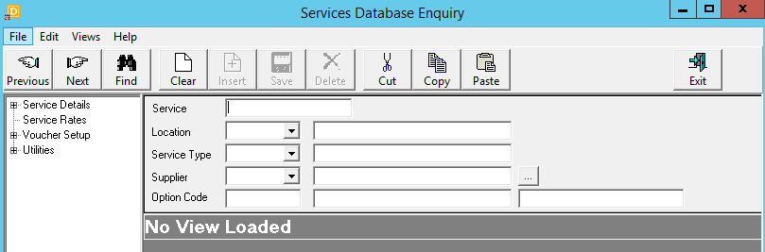

Select “Order by: Name”, type the name in the search criteria field and click “Search”.

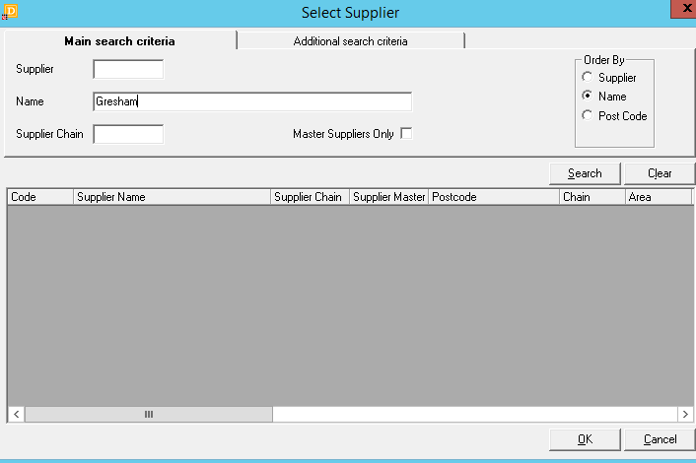

Double click on any of the fields and then click on “Find”.

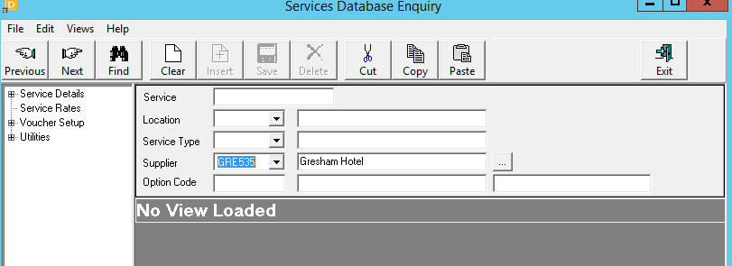

Double click on any of the options you are given and then select “Service Details” and below “Contacts” (top left). You will get a list of contacts whose details you can copy (See copy button on top).

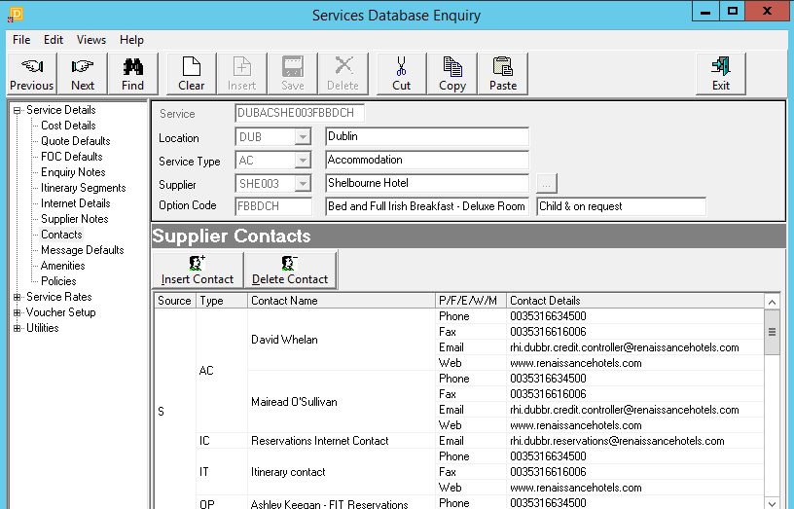

# E-Zine/Mailchimp/Subscription Form

This is a Marketing letter for all the delegates who have signed up for it in the past conferences.

Log in to Mailchimp and click on “Campaigns” on the top left side

Search for a conference (if there is an existing E-Zine already for this conference but a different topic) 🡪 Go to the right side where the arrow is and click on “Replicate” (the E-Zine is duplicated) 🡪 Click on the duplicate and you will see:

Recipients: Are the ones who will receive this E-Zine

Setup: Campaign name: UD&HEIT 2018 – Registration now open

Email subject: UD&HEIT 2018 – Registration will open December 2017

From Name: UD&HEIT Congress 2018

From Email Address: [udheit2018@abbey.ie](mailto:udheit2018@abbey.ie)

Design: Content: you can drag and drop text boxes, dividers, images, etc. from the right field into the left field

Design: You can add the footer/ header etc.

Change each box:

🡪Click on a text field on the left to view the options

🡪By clicking on the “dots” icon on the left you can drag the field somewhere else

🡪By clicking on the “pen” icon you can change the font /colour / alignment

🡪Click on “Preview and Test” on the top and select “Enter preview mode”

🡪If everything looks good (make sure to check the spelling and if the links are working) you can click on “Preview and Test” and select “Send a test email”

🡪Click on “Save and Exit” and select “Log out”

Confirm: When the project manager gives the OK you can send the E-Zine by clicking on “Confirm”

List of recipients: In order to create a list with contact details to send the e-zine to, click:

Lists 🡪 Create 🡪 Add contacts 🡪 Import contacts

🡪 You can only upload CSV files, so if you have an excel list just convert it to CSV

**How to add a sign in form to the website:**

1. Go to Audience -> go to manage Audience and select: view Audiences
2. Use an existing list (replicate the list & rename it, go to the arrow next to “Stats” and select replicate) if there is one, otherwise create a new one (it doesn’t matter if it does not have any subscribers yet)
3. Search for the list (usually at the bottom) and select it and click on “Signup forms”

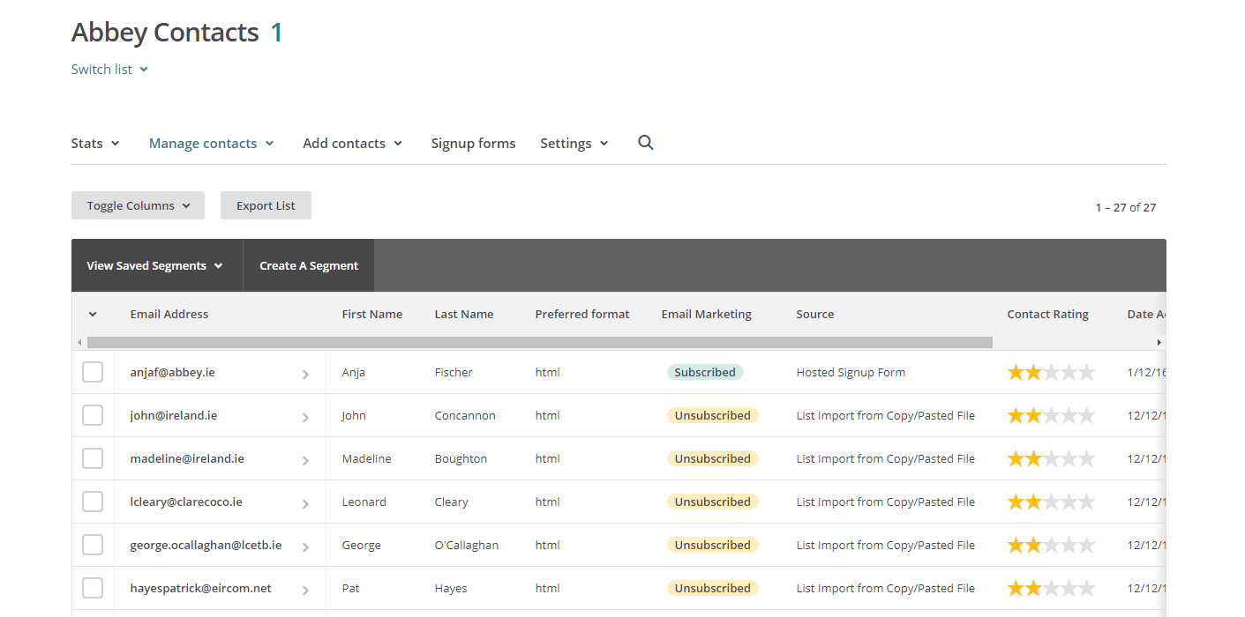

1. Select “embedded forms”

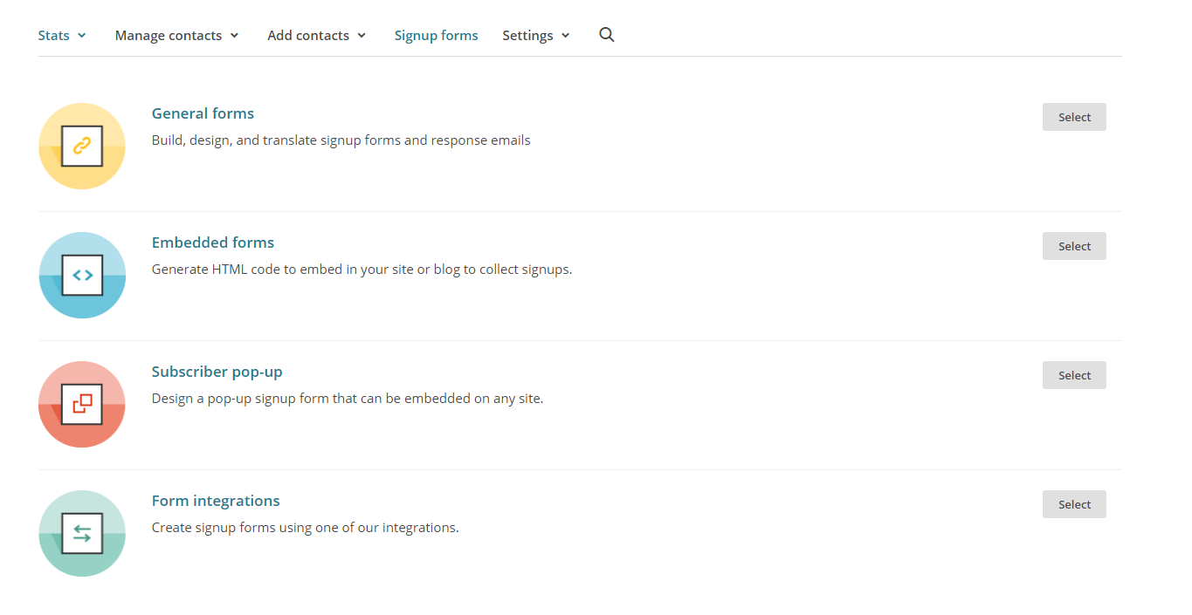

1. I generally use the classic form with only the options selected below.

You can make fields required if you like in the “form builder” (on the left side, small text in blue).

Edit in the “form builder”:

* The title (double click)
* Go to Field settings (on the right Hand side). There you can edit the text. Change the Conference name and E-Mail address)

1. Go to Settings. Select “Audience name and campaign default”. Here you need to change the Audience name, Default From name and Default from email address. Don’t forget to save.
2. Go to Settings again and select “Required email footer content”. The Company, Contact name and Email address need to be changed.
3. Once you’re happy with the form, copy the whole html link below.

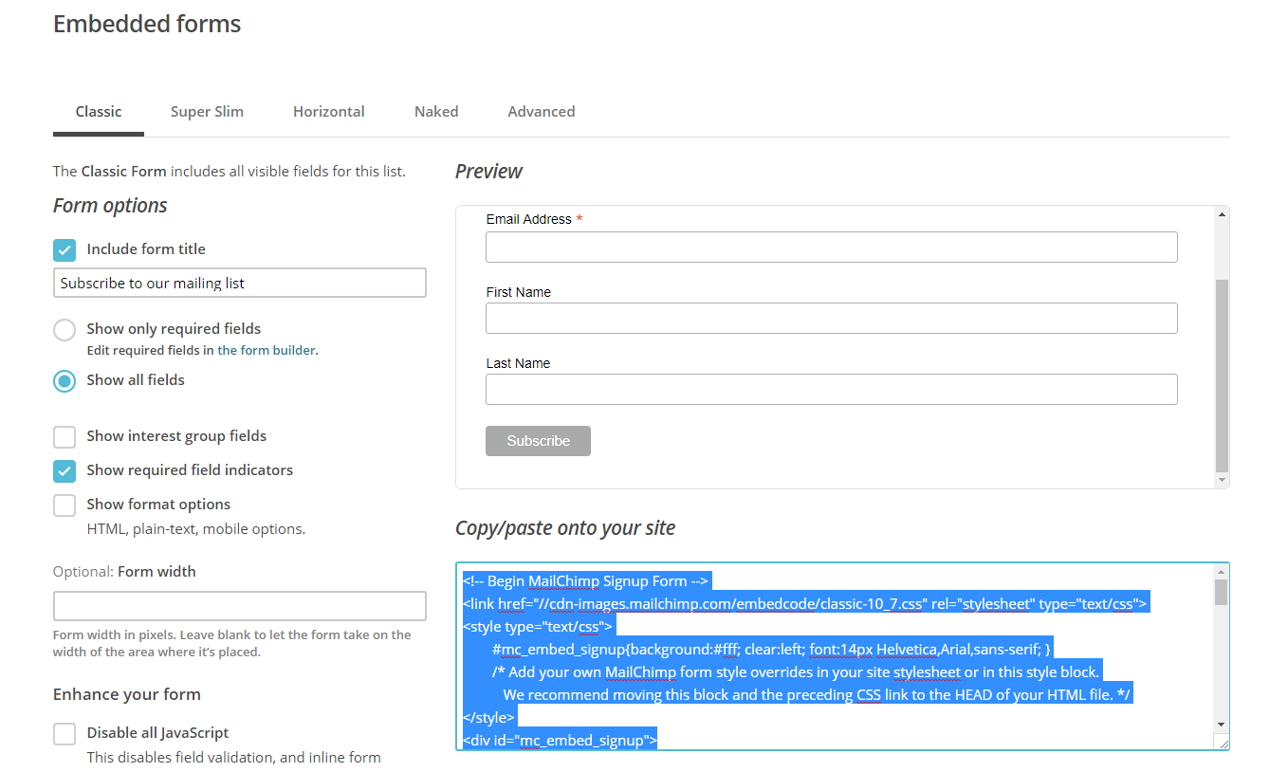

1. Open the website in the Wix editor and click on “add”, “more”, “html code”

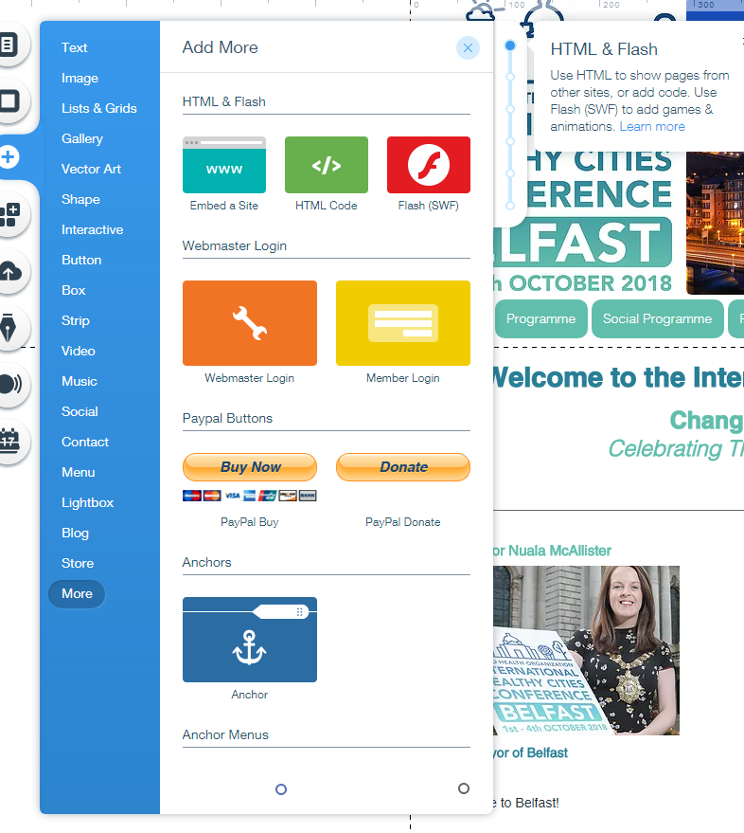

1. Click on “enter code”, select code and paste the code you copied from mailchimp in the fields.

1. Another way to add the “Subscribe Button” to Wix is to click on “add”, “button”, select one and click on the hyperlink symbol. Then select “Web Address”, “New window” and paste the URL (described below) into the field.

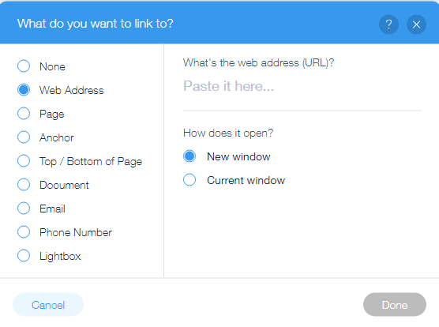

1. You can find the URL on Mailchimp, Embedded forms, ”signup forms”, “the form builder”, copy the “Signup from URL” and paste onto the wix website into the URL section.
2. To double check if the signup from is correct, add your details and then check if your details have been added to the mailchimp list.

**Mailchimp/Subscription form**

The button “Please subscribe here to receive further updates” can be found on almost on all websites.

In order to create the subscriber form you need to log in to Mailchimp:

Username: NicoRol  
Password: AbbeyConference20!8

1. Click on “Lists”
2. Replicate any list of the existing ones (arrow on the right side) and rename it to the conference for what you would like to create a new list/subscriber form
3. Click on the new list you created.
4. Click on “Settings” and on “List name and defaults”. Make sure all three options for the form settings have a small hook.

In “Campaign defaults” below, insert the name of the conference and year in “Default from name”. Insert the conferences email address below.

1. Click on “Settings” again and on “Required email footer content”.

Insert “Abbey Conference & Events” in Company and Contact gaps and the address details of Abbey  
Very important: At the very bottom please insert the website URL of the conference

Click save

1. Click on “Signup forms” (next to “Settings”) and click on “Form builder”
2. When you click on the arrow for “Signup form” you can choose between the different pages. Only the first forms are relevant that belong to “Subscribe”.  
   “Signup thank you page”: Insert the conference email address and hyperlink  
   “Opt-in confirmation email”: Insert the conference email address and hyperlink  
   “Confirmation thank you page”: Insert the conference webpage URL and hyperlink  
   “Final welcome email”: Insert the conference email address and hyperlink
3. Click on “Form builder” again and copy the hyperlink of the Signup form URL
4. Insert the link as a hyperlink to the button “Subscribe for updates” on the website via Wix (See No. 16).

# Surveymonkey

You can create a survey to send to all delegates after the conference took place

🡪surveymonkey.net User name: Abbey_tours PW:conference

🡪Create a copy by swiping over a conference name, click on “More Options” and click on “Make a copy”

🡪You can now create new questions and fields 🡪Save and send a test survey to your email address

# ICCA Database

ICCA - the International Congress and Convention Association - represents the world's leading suppliers in handling, transporting and accommodating international meetings and events, and comprises over 1,000 member companies and organisations in almost 100 countries worldwide. Since its establishment over 50 years ago, ICCA specialises in the international association meetings sector, offering unrivalled data, communication channels, and business development opportunities.

The association market covers a wide range of meeting types and categories: medical meetings (the largest segment); scientific; other academic; trade organisations; professional bodies; social groupings. In terms of size, budget, duration and complexity there are massive variations between and also within categories. However, some similarities can be identified:

* Almost every ‘specialty’ has an association which holds one or more meetings.
* Most associations have meetings that are repeated at regular intervals. These can be annual, biennial etc.
* The destinations rotate. They rarely return to the same destination within a very short time-span.
* The initiative to host a meeting often comes from the local counterpart, e.g. the national association. If that body is difficult to motivate to organise the meeting, the chances are high that the meeting will be scheduled elsewhere.
* Association meetings have a very long lead-time; it is not unusual to find lead times of 5 years or more.
* It is estimated that a growing minority of about 25-30% of the decision-making processes no longer include an official bidding procedure, but have a “central initiator” who selects the location and venues based on pre-determined and strict criteria.
* It is estimated that there are approximately 24,000 different association meetings organised on a regular basis. The ICCA Association Database has collected information on approximately 80% of them.

**How to use the ICCA Database:**

“Find Association Meetings” 🡪 New search, Search by name if known

Otherwise select “potential meetings for” 🡪 “Advanced”, add your criteria and download it as an excel.

**Selection Criteria**

* Destination: Dublin / Ireland
* Attendance: between 500 and 3000
* Rotation area (select everything with Europe): must be any of Africa/Europe, Africa/Europe/Middle East, Asia/Europe, E.U. Countries, Europe, Europe/Interamerican, Europe/Japan, Europe/Latin America, Europe/N.America/Asia, Europe/N.America/Japan, Europe/North Africa, Europe/North America, North Europe, Outside North America, World/International
* Destination(s) not visited: later than 22-08-2007
* Recurring destination
* Local reps based in: Ireland

ICCA also provides info about local ambassadors, industry topics etc. to see that click on “ICCA Big Data Search”.

ICCA Tutorials, helpdesk etc. can be found here: <https://iccadev.atlassian.net/wiki/spaces/ADKBI/overview>

Info to be gathered from ICCA:

* Does the Conference have a Core PCO? (Look at the Business Exchange and if there is no info at each year individually)
* Which is the international Association hosting the conference?
* Has the conference been to Ireland before? If so when, where and who hosted it?
* Is it annual/biannual etc.?
* How many delegates approx.?
* Bid deadline?
* Rotation Area?
* In short, all the info you can get!

When you found a conference, select it to analyse it in further detail.

You will find the fields “Essentials”, “Organisation”, “Business Exchange”, “UAI Info”.

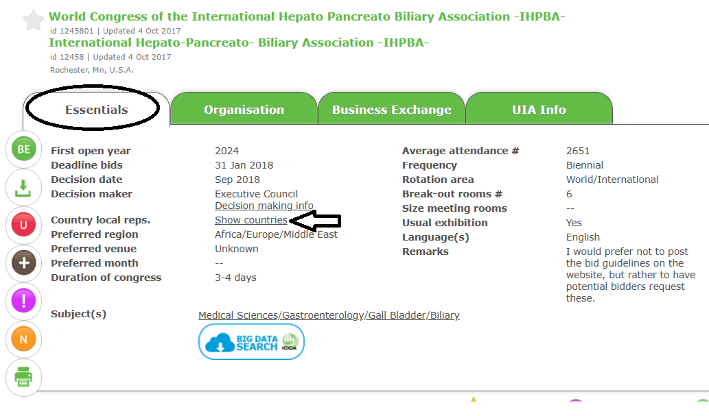

Under “Essentials” you will find all the general data. You can click on “Show countries” to see if there is an Irish member association that might be able to bring the conference to Ireland. The link usually will lead you to Irish member contact details. These people should be contacted, as they might become conference ambassadors.

The “Organisation” tab provides info about international organisation, such as the website that should be searched for a bid manual etc.

The “Business Exchange” tab shows important info e.g. about the venue, bidding process etc. provided by former hosts of the conference.

# Databases that need to be updated (Venue folder, Mail Database, Irish Associations)

Currently these Databases are being updated and still need to be finished:

1. Supplier Database

In order to complete the database go through the Outlook folder (Outlook: Public Folders 🡪 Conference & Corporate 🡪 Conference Confirmed) and add supplier details to the excel sheet here (C&E, Business Development, Databases, Supplier & Industry)

🡪 The contacts from 2020-2017 have already been added, so move upwards from 2016 EPP Tour Venues

1. Venue Folder

Add details to the venues found here: Conferences & Events 🡪 Venues

The venues are broken down further by city. Some venues do not have any info; they should be completed with the info found on the city’s convention bureau website (e.g. search for Dublin Convention Bureau) or the venues website itself. Useful information, images, capacity charts, floorplans and videos can be added.

Whenever a new venue is used in a proposal, the info should be added to the folder.

There is also an email folder with information that venues have sent over the years – Conference & Corporate/Business Development/Greg/Hotels&Venues

# Irelandscontentpool

Ireland’s content pool is a website which provides public domain images, so they can be used for presentations, published on the websites etc.

# Sugar CRM

SugarCRM is a customer relationship management (CRM) solution we use to save info about conference bids and conferences we won.

Website: crm.abbey.ie

Username: CEBD

Password: S4Xv74

This is what the menu looks like.



At the moment we only use the “Opportunities” tab to add conferences from this spreadsheet here. (C&E, BD, Leads Analysis)

Add the details from the spreadsheet, for the “Type” always select “Conferences & Events”.

Once a bid is won, the “Opportunity” can be converted into a “Project”.

Search: In order to use the search function use a % before your search word to see all results including the word.

E.g. if you use %radiology then you will see all results with Radiology in the name

Denomination:

Account – Name of Organization

Contact: Name, Surname

Opportunity: Year, name

Tags: Convention bureau, Venue, City, Topic/Field, Year,

If you have any problems with Sugar CRM, call Ray Queeney (Infosystems)

Approach:

Go into the n-drive. Conference & Events -> Business Development -> Quotes -> Lead Analysis -> Excel Spreadsheet (2016-2019 Leads Analysis).

Go through the list and insert all Conferences listed there in the CRM database. Don’t make any changes on the spreadsheet. There is a copy also in Leads Analysis folder, work on that. You can highlight which conferences you have already inserted in the conferences or which you couldn’t allocated.

On the CRM website:

1. Frist click on “opportunities” to check if the conference is already saved in there, if not:
2. Click on “Accounts” and create a new account. Add in only the name of the organization or company the client of the conference is working for.

Search in the outlook folders under “2. Conference Quotes” for the specific conference folders. Look through the emails and check the client for the conference and the organization he or she is working for. You can also check on the n-drive under quotes for more details. Then add in the organizations name the client is working for in the “name” field. Then click on save.

1. Click on “Contacts” and create a new contact. Add in the clients name and title (if provided), and add the account name you have created before. Also insert the email address and phone number. Always save!
2. Click on “Opportunities” and create a new opportunity. Opportunity is the name of the conference. Always put the year before the name (e.g. 2019 EHLC). Select “Conference & Events” as the “Opportunity Company”. Select PCO type, that is listed on the Excel spreadsheet on the left side (e.g. DCB, CCB, VD< GCB, .. or other). Put in the number of delegates estimated (also check in folders, documents etc). Select if it’s a conference or event. And add the Bid Status. Select the year of opportunity, that means when the conference or event is taking place. Add the bid status and whether the event is international or European and click save.
3. Bid Status: Excel sheet (column “Stage”)
4. Bid Status: Excel sheet (column “Status”)

Confirmed: Conference will definitely take place in Ireland (Dublin)  
Confirmed bid: meet with client to bring the event to Ireland (Dublin)

Highlight the conferences you have already added to the CRM database in the spreadsheet. (red: done; blue: couldn’t allocate; green: not sure if allocated correctly – check with Greg)

# Wix - Websites

Wix is the program we use to design our conference websites.

By clicking on the drop down menu on the top left you will be able to see all our websites.

By clicking on the image and then on “Manage site” you will see all the different settings.

Click “Select site” to open them in the web or “edit site” so you can make changes.

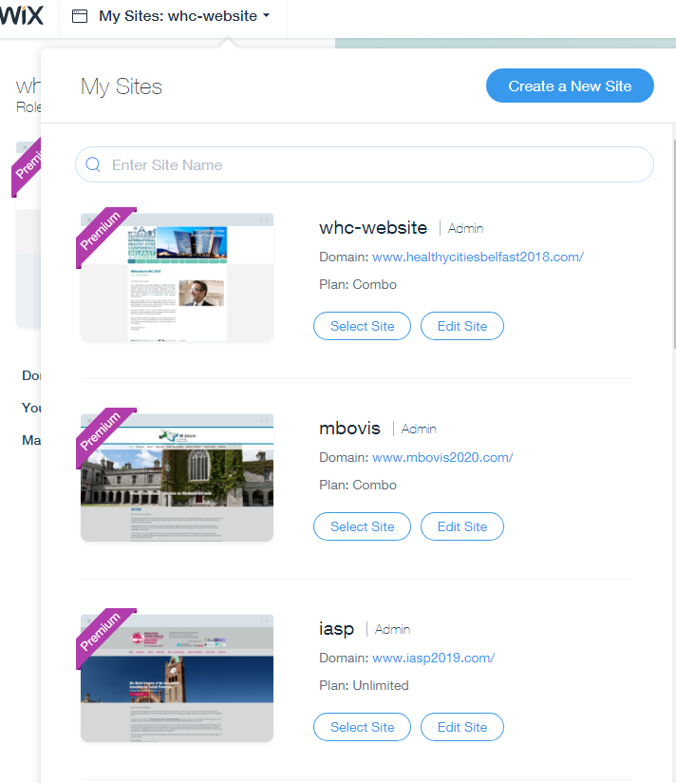

The most important buttons on the left are the following:

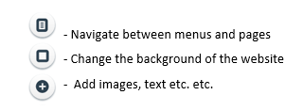

Always save your changes and publish them once you are finished (top right corner).

Once you finished making your changes in the editor, click on mobile view and make sure everything is shown correctly. You cannot make many changes in the mobile editor, but you can arrange the different objects.

When navigating in the menu you can add pages. In order to create a drop down menu on a page, click on the three dots and select subpage. Then drag it to wherever you want it. You can also hide pages, so visitors cannot see them.

# SEO and Google Analytics

**Step 1) Indicate how you want your website to appear on Google**

- Go to the Wix editor and “Manage pages”

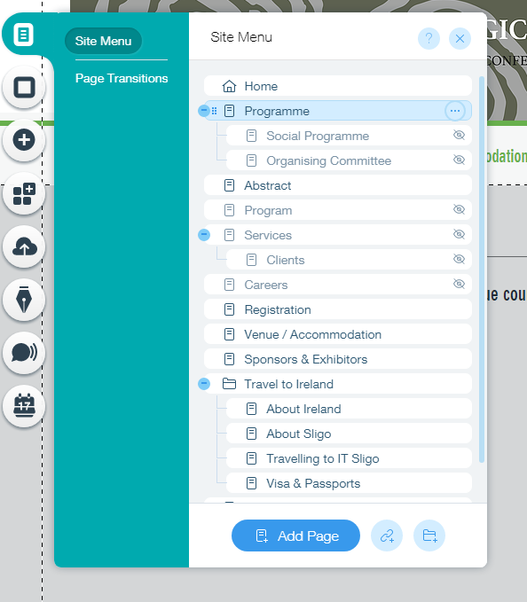

Click on the three dots and select Page SEO (SEO Google) 🡪 Then add Keywords, description, URL you want the site to appear on Google with.

Do this for each site.

**Step 2) Use Google Search Console to verify your website ownership**

<https://www.google.com/webmasters/verification/verification?hl=en&siteUrl=https://www.abbeyconference.ie/&continue=https://www.google.com/webmasters/tools/dashboard?hl%3Den%26authuser%3D0%26siteUrl%3Dhttps://www.abbeyconference.ie/%26sig%3DALjLGbMsEH9ljIoDtrPaJV_ZMzut_OD2OA&theme=wmt&authuser=0&priorities=vfile,vmeta,vdns,vanalytics,vtagmanager&tid=alternate>

Easiest method via HTML tag (Under „Alternate Methods”)

🡪 Add the Meta tag given to the website (Site Settings, SEO, click on add header code Meta tags

🡪 Once published click “verify” at the search console

Make sure you always “allow search engines to include your site in search results”! (See below)

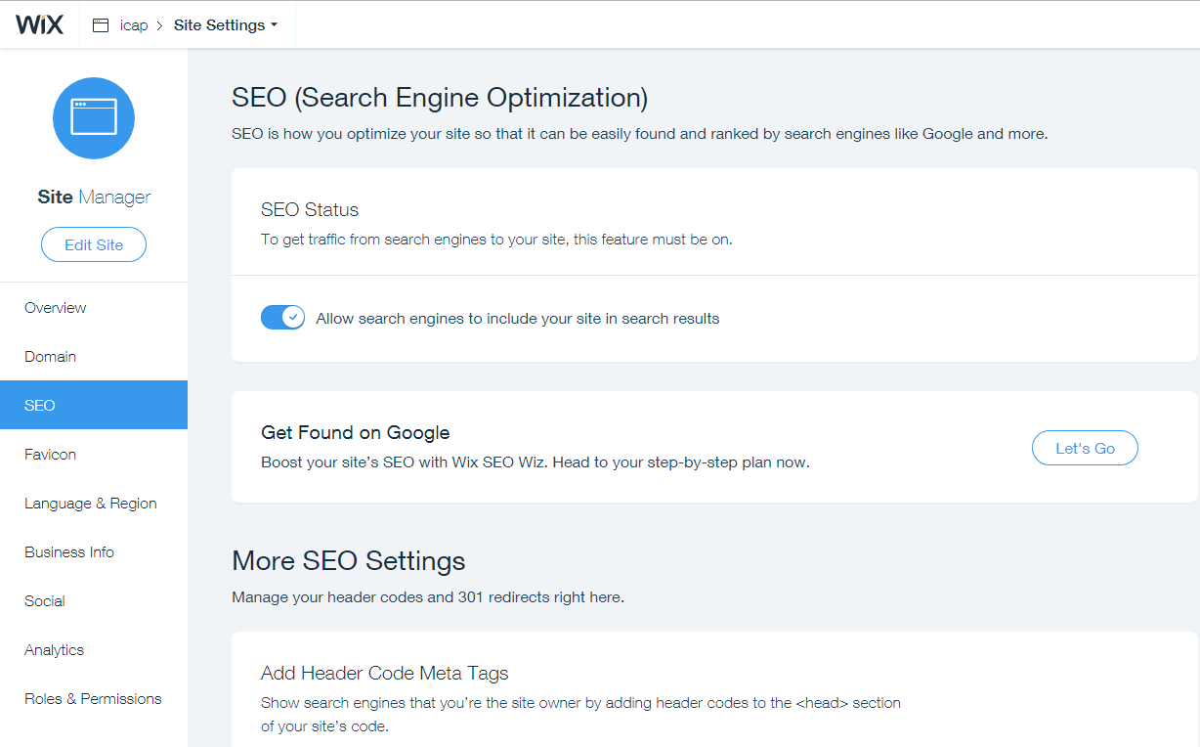

Step 2) Go to the Search Console Crawler (<https://www.google.com/webmasters/tools/submit-url?hl=en&mesd=AB9YKzIUeCFnRyCsS1trlzqpIuyVlvwbxrlQr4YkfOd9c8vyQEbHcDnErdg9unzYX1cHKzgDhXgmNCRw0XrV6PGX_L3i5VSj5vZqo-izbx_mosZ9Ml7rI6PxL8M0DtniM5ESzTBa3R6H&pli=1>)

Enter the Websites URL, this way Google is actively going to search for it.

Any time the description/title is updated the URL should be inserted to the Crawler, this way it is updated faster on Google!

Associate your property with Google Analytics

If you associate a Google Analytics property with a site in your Search Console account, you’ll be able to see Search Console data in your Google Analytics reports. To associate your property you have to verify your ownership first, as explained above.

You can do this via this link: <https://www.google.com/webmasters/tools/analytics-property-selection?utm_medium=incoming-link&utm_campaign=HelpCenter>

**Step 3) Google Analytics**: <https://analytics.google.com/analytics/web/#embed/report-home/a112284000w167372190p167622364/>

Enter Google Analytics and click on Admin (See below)

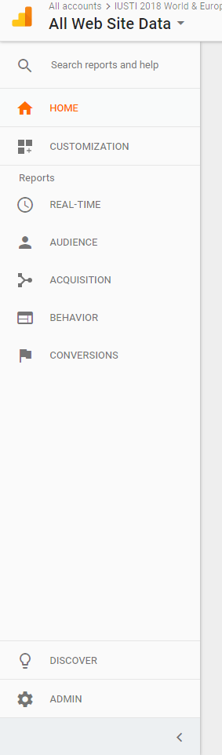

Then Select the Property drop down menu and click “Create new property”

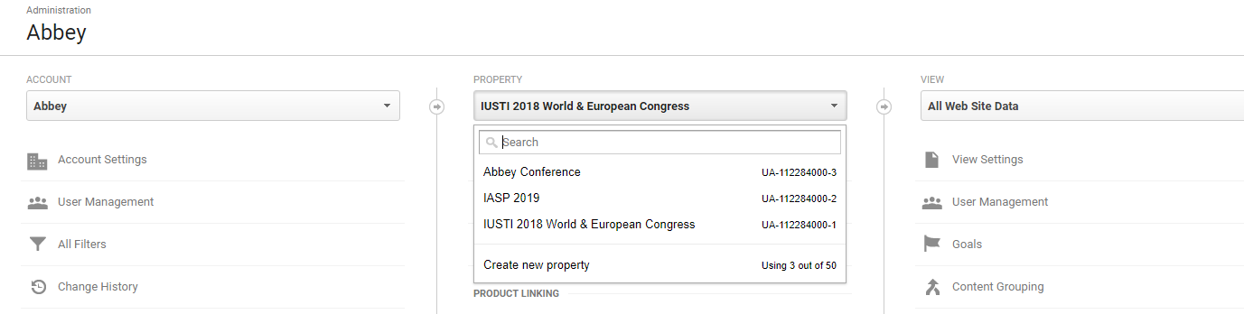

- Enter the details and get the Tracking ID

- Send the ID and the Website’s name to Amy, only she as the website owner can then use the ID to set up Google Analytics in Wix

- If you then select “All website data” for a site, you will be able to see all statistics

**Apply a Filter**

In order to exclude clicks from within Abbey, you can apply a filter (Under “All Website Data”). Exclude all IP Adresses that are equal to:

* 89.204.241.32
* 89.204.241.33
* 89.204.241.34
* 89.204.241.35
* 89.204.241.36
* 89.204.241.37
* 89.204.241.38
* 89.204.241.39
* 89.101.237.240
* 89.101.237.241
* 89.101.237.242
* 89.101.237.243
* 89.101.237.244
* 89.101.237.245
* 89.101.237.246
* 89.101.237.247

**Sitemap**

A Sitemap is a list of pages on a website that is accessible to all users. An XML sitemap is a way for website owners to tell search engines about all the pages that exist on their website. While sitemaps do not boost your search rankings, it allows search engines to better crawl your website.

How to add a sitemap to your website:

Enter Google Search Console and select a website. In the dropdown menu “crawl” select “sitemaps”. In the top right corner select “add/test sitemap”.

Add sitemap.xml which contains link to your other sitemaps. You can either submit sitemap_index.xml alone or submit all other sitemaps one by one. By submitting sitemap_index.xml alone, Google will automatically discover other sitemaps and crawl them.

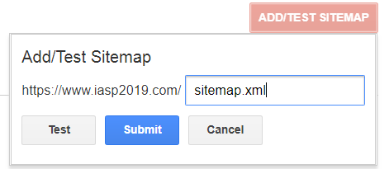

**More detailed approach for SEO Google:**

**SEO Google**

If you would like your conference website to appear higher in the google searches you need to connect the website with google:

1. Login to wix and choose a website. Please click on “settings” and then on “click found on google”  
   Username: [greg@abbey.ie](mailto:greg@abbey.ie)  
   Password: abbeyconference
2. Goal is to achieve as much small green hooks as possible.
3. The boxes with the exclamation marks need to be updated. Click and them and click on “Go to Editor” to make the change.
4. After you have done your change, make sure to click on refresh next to the “Go to Editor” button

Sometimes you can’t update everything, e.g. (add social links: because not all organizations have twitter, facebook, etc..)

1. Most important are the SEO title, the keywords, the page URL, and description of each pages on the website  
   Click on the three dots next to the pages on the menu.  
   Then click on “SEO & Social”.  
   There you can add description on the page (same description for all pages – date, location, name of event)  
   Enter the keywords: name of event, year, location, etc  
   Also make sure to create a title that differentiates from other titles on other websites  
   A lot of times it happens that you just copy the page from another to create a new one. Then it happens that the URL is “copy of …”. Please change it, as well as the title! Always make sure to update the SEO when you add a new page.

When you make changes, it will not immediately be shown on the internet as it needs time to connect to google.

# Bid production

When bidding for a conference we usually have to submit certain documents and present our company.

All the bids can be found in the “Quotes” folder (C&E, Quotes).

Unless the client provides us with templates, we use our own ones. A current example can be found here: N:\Conference & Events\Quotes\2024\2024 IHPBA\Presented.

In order to prepare these documents research on the conference should be conducted. Usually this includes:

- The conference: All data from ICCA (Business Exchange, Meeting editions and the locations,

Usually we have to prepare a PowerPoint presentation, a budget and a timeline.

* **PPT presentation:** The presentation needs to be updated with the association’s logo, new dates and info, prices, social programme pictures of the venue, new venue and gala dinner options, potential sponsors in the field of the conference etc.
* **Budget**: The budget needs to be updated based on info from the bid manual (if provided), former conferences or the convention bureau/client/venues. Aspects to be updated are amongst others:

- Venues (for the conference, gala dinner etc.) should be contacted to get quotes (including prices, rooms etc.)

- Delegate numbers

- Association logo

- Registration categories and prices (usually found on former conference websites)

- Number of coffee breaks, sessions etc. (Found on former programmes)

* **Timeline**:

- First add the dates known (usually the conference and the presentation dates)

- E-zine: always the last Tuesday of the month (check the E-Zine in December, it usually says: send Christmas E-Zine)

- Meeting: always the first Tuesday of the month

🡪 Adapt the rest of the dates accordingly

To make the presentation easier research should be conducted on the following:

* The conference
* Former conference programme
* The conference topic
* The international association
* The Irish association
* The presentation committee (if known): e.g. found on Linkedin, Facebook, Twitter etc.
* Summary of all the relevant info from the Convention Bureau

Important documents to be searched and downloaded:

Bidding manual, former conference programme with sessions, meeting editions from ICCA, Business Exchange from ICCA

**For the presentation all these infos should be printed and put together as a brochure. The usual order is: PPT Presentation on the top, then timeline and last the budget. All pages of the budget should be printed landscape (even though they do not fit on one page then!)**

# General info

**Save s.th. as pdf:** Select “Document” and unclick the rest, this way the format will stay the same.

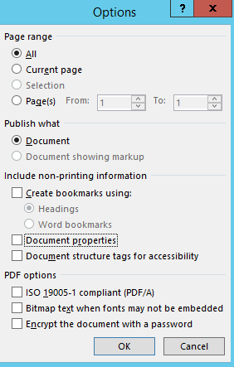

**Printers:**

2nd floor: INEO

1st floor (our office): small one (temp), big one (Sharp MX)

# Conference Glossary

**Abstract Management** – Collection of the submissions in a databank 🡪 assessment by the scientific committee 🡪 selection and invitation of speakers; the abstracts that have not been selected are shown in the poster area, poster presenters are informed

**Accompanying Person** – Guest, partner or spouse of attendee

**Ambassador** – a person of knowledge and stature, influential in their field, who can act as a representative of a destination and is prepared to work with local meetings professionals to secure conference business for that destination

**AMC = Association Management Company -** An AMC provides management and specialized administrative services to associations. Many AMCs serve as an organization's headquarters, managing day-to-day operations.

**Attrition** – Hotel contracts: An attrition clause in the contract is a commitment to pay for a specific number of rooms and should your number decrease, this reduction of numbers may require a payment as a penalty

**Badge** – Identifying sign, tag or emblem worn by event participants

**Bradge** – Combination of badge & programme in one

**Client** – The individual, company, agent or person booking the event

**Congress Bidding** – Process of acquiring congresses for your destination

**Commission -** A payment (usually stated in the contract in %) made to us for bringing business to a company, e.g. for each room booked in a hotel by our delegates

**Delegate** - Person who attends a conference

**Failte Ireland -** National Tourism Development Authority in Ireland, provides funding and support for conferences in Ireland

**Keynote Speaker** – Headline speaker, “celebrity”, usually is being paid to speak

**Invited Speaker** – This speaker is being invited because of his relevance in the field

**Accepted Speaker** – This speaker sent in an abstract that was accepted as oral presentation

**Poster Presenter** – Sent in an abstract which was accepted by the committee as poster presentation

**Lanyard** – A cord passed round the neck to hold a name badge

**LOC** – Local Organizing Committee (can be our client): The LOC is responsible for planning and executing certain aspects of the Conference and reports to the Executive Committee via the Organizing President. The LOC usually includes representatives of the host country and/or institution.

**Name tent** – Is a folded paper which usually shows the logo and name of a sponsor / exhibitor at a conference

**DMC=Destination Management Company -** A DMC is a professional services company with local knowledge, expertise and resources, working in the design and implementation of events, activities, tours, transportation and program logistics. E.g. Abbey Ireland & UK

**Convention Bureau –** A convention and visitors bureau (CVB) is an organization that promotes a town, city, region, or country in order to increase the number of visitors. Associations often get in touch with convention bureaus that then invite us to bid for the conference. Each major city has its own Convention Bureau.

**Lead –** A lead is a conference we are interested in bidding for, as it might be profitable etc.

**PCO = Professional Conference Organiser –** A company which specialises in the organisation and management of congresses, conferences, seminars and similar events. E.g. Abbey Conferences & Events

**Core PCO –** A Core PCO is a PCO that is contracted on a framework agreement basis for a specific time period, by an International Association to handle the core tasks of regular, recurring meetings wherever they are held such as:Destination bids**,** Venues**,** Budgeting**,** Conference website**,** Marketing**,** Registration**,** Accommodation**,** Abstract handling**,** Event production**,** Social programme**,** Sponsorship and Exhibition etc.

**Quote** – A quote is a conference we are bidding for/preparing a bid for

**Venue –** Where the conference takes place (Hotel etc.)