1. Supplier/Agent Set up

**Speaker reimbursement:**

People who speak at a conference are called speakers and will sometimes get complimentary registration and often accommodation and dinner tickets as well.

They will organize and pay for their flights/taxis/trains etc by themselves and later on they can get those expenses reimbursed from the LOC (Local Organizing Committee) which we take care of.

You will need to send a Speaker Expense Form (they need to fill out their expenses, bank details, address). You can find this form on the <https://web.abbey.ie/onlineforms/> In addition they need to send all receipts of their flights/taxis/trains etc.

🡪When you receive the filled out form you can save it in each individual speaker folder in the conference folder.

🡪You can tell the speakers that it will take 2-3 weeks to process the refund

🡪Sum all the expenses up and convert them into € ([www.xe.com](http://www.xe.com)) look for the date when they bought the ticket and convert it

🡪Put everything into an Excel file

🡪Put the expense form and the receipts into one pdf document

🡪If the speaker does not have a Supplier Code yet you will need to set one up

This is for example to set up a **supplier or speaker** **to pay or reimburse** them. After setting up the Supplier you will receive a Supplier Code and it goes into tourplan.

All speakers are set up as suppliers, and **Conference** before you click on generate.

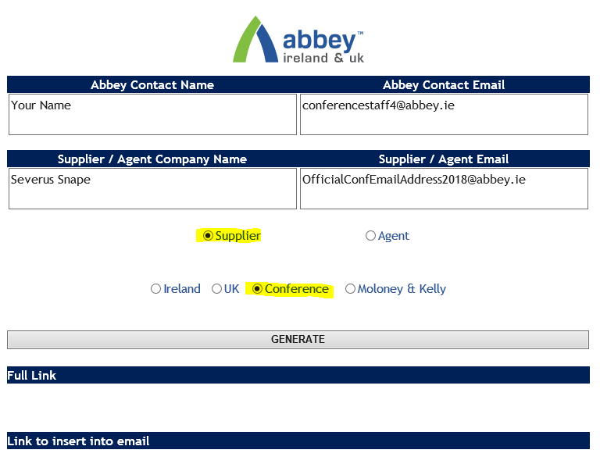

You then click on the appearing link, which leads you to the Supplier Setup Form.

As indicated in below picture, you fill out your name and conferencestaff email address **twice** in the first section of the form. Under 1) you then fill out the speaker’s details. You’ll need her/his address (usually their **home address** not their university’s) to do this. As **country**, you only have the **limited options** of the current Abbey operating locations (England, Northern Ireland, Republic of Ireland, Scotland, Wales). In this example I selected **Republic of Ireland** rather than England because the form will then be sent to our **Dublin based TP colleagues** (rather than to those in London), who I can then ask to change the country to whichever country needed to fill out the address.

**Speaker**: “No”, they are **not VAT registered** and **Supplier Type “Speaker”**

**Supplier**: “Yes”, they usually have a **VAT number** on their invoice and **Supplier Type “Other”**

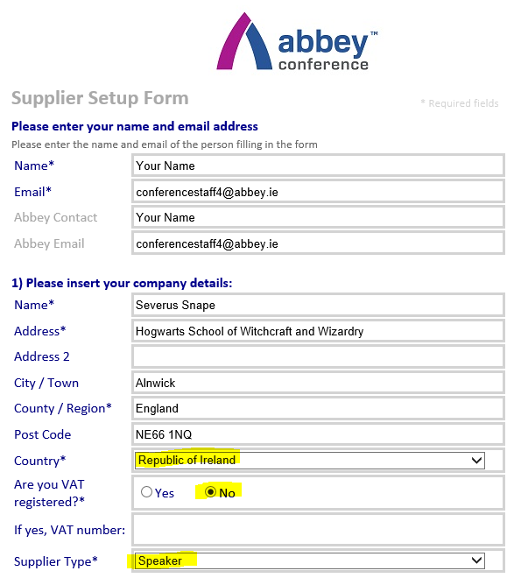

Next step 2) - filling this form in for a **speaker** you will just put **your own (work) Phone and Email** under “Accounts*” and “Main Contact*” and then select “**Use same details for all contacts**”.

Filling in this form for a **supplier** you will put in their contact details (usually accounts manager) plus website

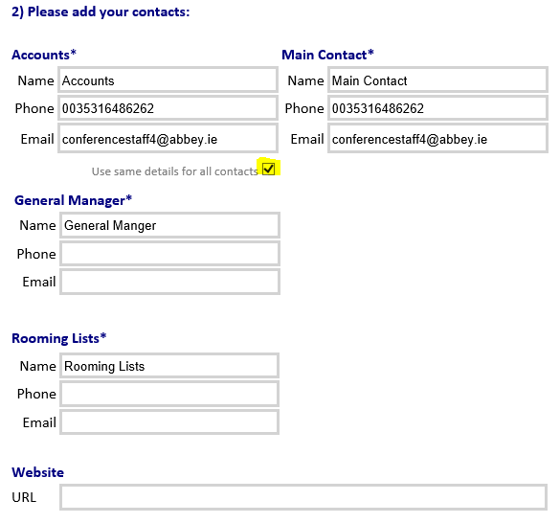

And the last step is filling in the speaker’s bank details which always includes Bank Name and Account Name. In case you select **EUR** as currency, you will have to fill out **IBAN** and **BIC**. And if standard payment terms apply you will leave the default setting “Standard 30 day credit terms apply”.

The last step for the speaker reimbursement is to include information about VAT in the “Any further information box?”, which is 0% for speaker expenses hence “**Speaker Expenses @0% VAT**”.

If **Supplier** we usually have VAT: “**Printing @x% VAT**.”

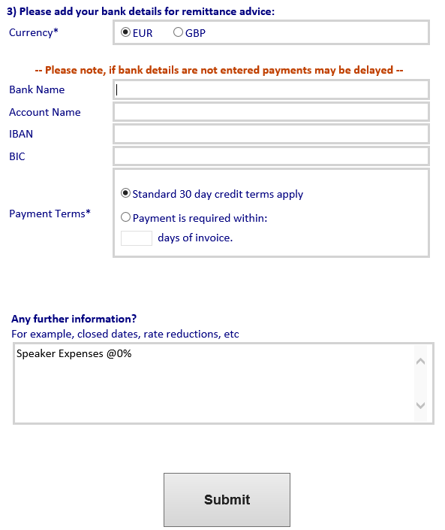

If you don’t have IBAN and BIC but a **Sort Code** and **Account Number**, you can select **GBP** as currency to fill in 3). If a speaker needs to be reimbursed in USD (or any other currency and they don’t have IBAN and BIC), you can also select GBP on the supplier form, and then **ask Tourplan to set up the service line in** USD. You can include this request in “Any further information?”.

“Please set up in xxx”(insert currency the speaker will be reimbursed)

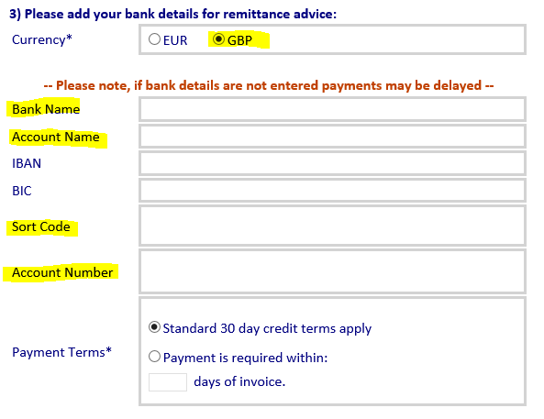

You then wait for your Tourplan colleagues to set the speaker up as a supplier on TP. Once they have done that you will receive an email with a **supplier code**, which is usually the first three letters of the speaker’s name plus 3 digits, e.g. **SNA500**.

**Set up Agent**

This is for example to set up a **client**. After setting up the Agent **you will receive an Agent Code**

🡪Open the Internet Explorer 🡪 the **Intranet** will open 🡪 Click on “**Supplier & Agent Setup**” on the left side 🡪 Click on the **link** provided:

Abbey Contact Name: Your name

Abbey Contact Email: Your email address

Supplier / Agent Company Name: Conference name

Supplier / Agent Email: Conference email address / Contact email address

🡪Select “Agent”

🡪Select “Conference”

🡪Select “**English**”

🡪Click on “Generate” 🡪 Click on the “here” which appears on the bottom

Name: Your name 🡪 Same for Abbey Contact

Email: Your email address 🡪 Same for Abbey Email

1) Name: Client’s name

Address: Client’s Street

Address 2: other address line if provided

City / Town: Client’s city

County / Region: Client’s county / region

Post Code: Client’s Post code

Country: Only a few countries available (if not available select “Republic of Ireland”)

Are you VAT registered?: Select “No”

Agent Type: Select “Other”

2) Name and Email address of client (usually Accounts Manager,…)

**3) & 4) doesn’t need to be filled out**

5) Conference & Events

6) Ireland

7) Type of conference

8) Select “Other”: Client for Conference

🡪SUBMIT

# Tourplan

🡪 Tourplan is where we have to put in all the expenses we have for each conference. This needs

to match the budget at the end to sign the conference off

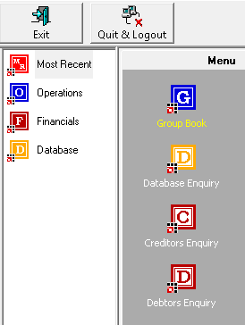

Put expenses into Tourplan which need to be paid

Look up a supplier to find out the Supplier Code

See details of Supplier like address, currency and the amount reimbursed

See details of Agent like address, currency and the amount paid

1. 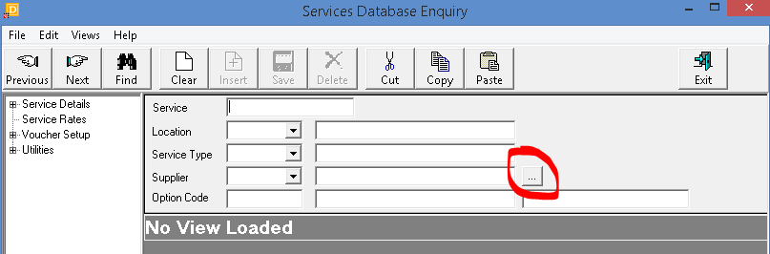Look up Supplier Code: Go to the Menu and select “**Database Enquiry**” 🡪 Click on the **three dots** next to the Supplier field 🡪Insert the name (first name / last name / company name) in the “Name” tab and click on “**Search**” 🡪If nothing appears the Supplier hasn’t been set up yet (see “Set up Supplier Code”)
2. Look for Supplier details: Go to the Menu and select “**Creditors Enquiry**” 🡪 Insert the **Supplier Code** in the “Supplier” drop down field (consist of the first 3 letters of the first name / company name and 3 digits “SUS001”)

🡪**Details**: The suppliers address will appear right next to the code and on the bottom at the details section as well

🡪**Currencies**: Click on “Currencies” on the left 🡪 The currencies will appear on the right

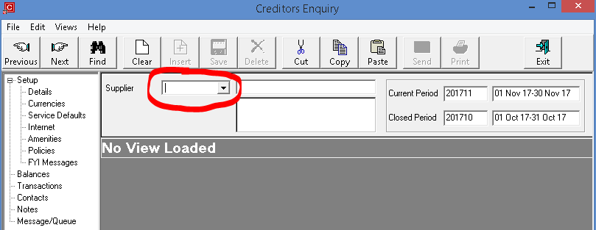🡪**Transactions**: Click on “Transactions” on the left 🡪 All the transactions made will appear on the right (date, conference name, conference code, currency, amount)

**Debtors Enquiry:** See Creditors Enquiry

1. Put speaker expense into Tourplan: When you set up a Supplier Code via the online Supplier Form you should receive the **Supplier Code** from **Informationsystems** (for example “OCB001”)

🡪Go to the Menu and open “**Group book**”

🡪Type in the first letters of the conference in the “Name” field and click on “Find” on the top left side

🡪The conference name with all the details will appear

-Conference Reference Code on the right (COAC377652)

-Conference Agent Code on the top (EUR164)

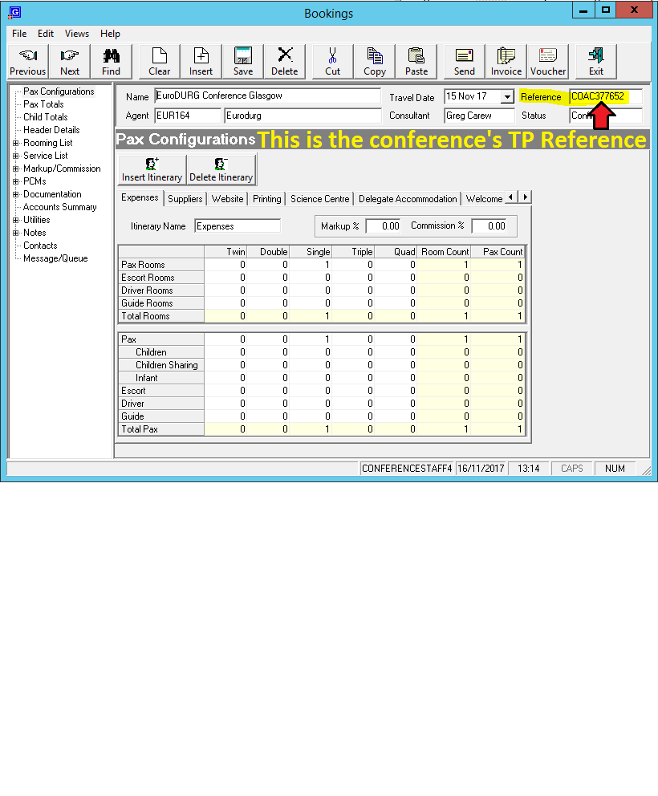

Open, login and click on “**Group book**”. Search for the **conference** (click “**find**” in order for TP to start the search) (🡪 double click on the correct conference if it doesn’t come up) 🡪 click on “**service list**” on the menu on your left hand side 🡪 find the appropriate tab e.g. “**speaker expenses/costs**” / “**printing**” etc. 🡪 click “**insert**” (upper menu).

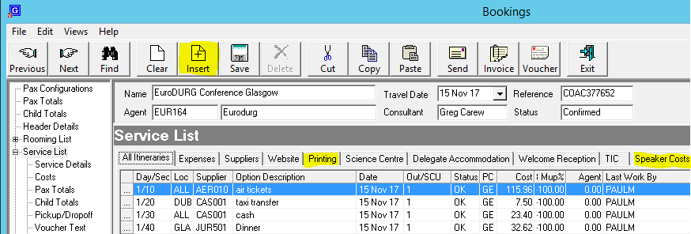

Fill in your **Supplier Code** (SOF002) as indicated in the picture below and make sure that the Status is on “**OK – Confirmed**”. Then click on the “**scroll services**” tab, **double click** on the correct line indicating the **speaker’s name and currency**, make sure the **status is on OK** and **save**. Now you can enter the amount of the reimbursement in the newly opened window.

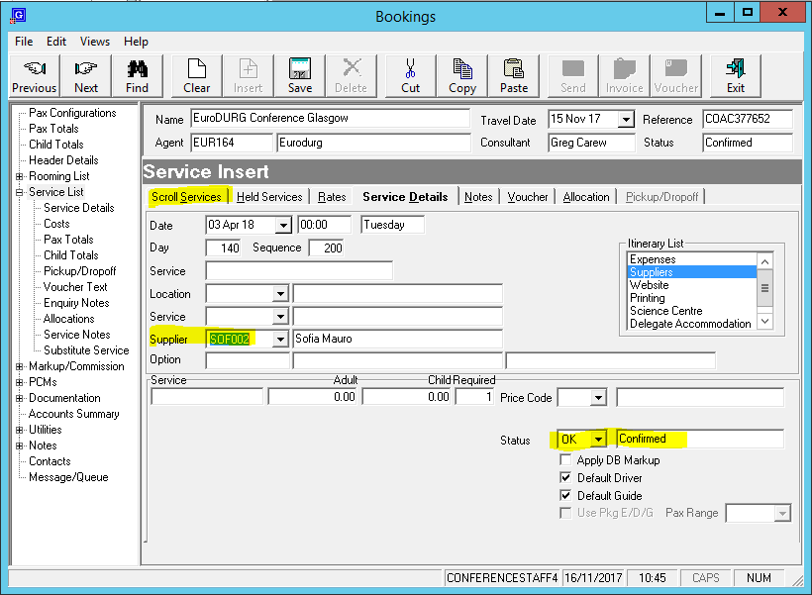

In case you are dealing with an invoice in GBP and you have “Cost (GBP)” and “Sell (EUR)”, you can just fill in the same amount in both boxes, e.g. £450.00 as on invoice. Then you go back to Service List. Double-click on your newly created insert and amend the EUR Sell amount to 0.00 (see picture below). Save.

(you do not have to fill out the “Sell” Cell if it is not charged to the client. That means if we pay for it “Cell”, if the client has to pay it back to us “Sell” as well)

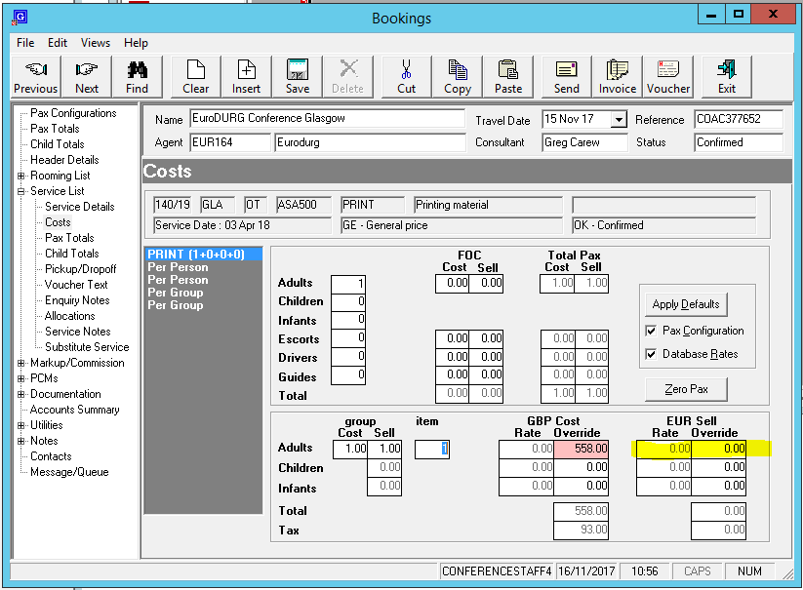

If a speaker needs to be reimbursed in USD, you can select GBP on the supplier form, and then ask Tourplan to set up the service line in USD (cost) and Euro (sell). For the USD (cost) amount, you should have the speaker’s receipts which show the sum and for the EUR (sell) amount you can check the conference’s budget on the ndrive or ask your manager how to proceed. (E.g. convert using the exchange rate of the date of the receipts)

Use the following link for **exchange rates**:

<http://www.xe.com/>

You can add a note to have further information later on: 🡪Double click on the **expense** 🡪Click on “**Service Notes**” on the left 🡪Select “**Invoice Notes**” in the middle 🡪Put in the information and click on “**Save**”

✉

The last step now is to send an **email to accounts** asking them to reimburse the speaker.

This email needs to be addressed to: [accountspayable@abbey.ie](mailto:accountspayable@abbey.ie) and cc: [patrick@abbey.ie](mailto:patrick@abbey.ie)

Subject: Speaker Reimbursement “Conference Name”

Text: Hi, Please reimburse “Speaker Name” (“Supplier Code”) in next payment run. Please find attached the Speaker Expense Form and receipts. Reference is “insert the conference’s TP reference”. Many thanks, xy

Don’t forget your **attachments**, this should be the **Speaker Expense Forms** and **receipts / invoices or emails** of the client / supplier stating the amount they receive (insert the expense form and receipts into one document and convert it to a pdf document)

Look up if payment is processed: 🡪Go to the menu and select “**Group book**” 🡪Look for the **conference** 🡪 Click on service list on the left 🡪double click on the **expense** you want to look up 🡪If you click on the “**Cost**”or “**Sell**” Cell on the bottom it should not be possible to change anything 🡪If it is still possible to change the value it has not been paid yet!

