# E-Zine/Mailchimp/Subscription Form

This is a Marketing letter for all the delegates who have signed up for it in the past conferences.

Log in to Mailchimp and click on “Campaigns” on the top left side

Search for a conference (if there is an existing E-Zine already for this conference but a different topic) 🡪 Go to the right side where the arrow is and click on “Replicate” (the E-Zine is duplicated) 🡪 Click on the duplicate and you will see:

Recipients: Are the ones who will receive this E-Zine

Setup: Campaign name: UD&HEIT 2018 – Registration now open

Email subject: UD&HEIT 2018 – Registration will open December 2017

From Name: UD&HEIT Congress 2018

From Email Address: [udheit2018@abbey.ie](mailto:udheit2018@abbey.ie)

Design: Content: you can drag and drop text boxes, dividers, images, etc. from the right field into the left field

Design: You can add the footer/ header etc.

Change each box:

🡪Click on a text field on the left to view the options

🡪By clicking on the “dots” icon on the left you can drag the field somewhere else

🡪By clicking on the “pen” icon you can change the font /colour / alignment

🡪Click on “Preview and Test” on the top and select “Enter preview mode”

🡪If everything looks good (make sure to check the spelling and if the links are working) you can click on “Preview and Test” and select “Send a test email”

🡪Click on “Save and Exit” and select “Log out”

Confirm: When the project manager gives the OK you can send the E-Zine by clicking on “Confirm”

List of recipients: In order to create a list with contact details to send the e-zine to, click:

Lists 🡪 Create 🡪 Add contacts 🡪 Import contacts

🡪 You can only upload CSV files, so if you have an excel list just convert it to CSV

**How to add a sign in form to the website:**

1. Go to Audience -> go to manage Audience and select: view Audiences
2. Use an existing list (replicate the list & rename it, go to the arrow next to “Stats” and select replicate) if there is one, otherwise create a new one (it doesn’t matter if it does not have any subscribers yet)
3. Search for the list (usually at the bottom) and select it and click on “Signup forms”

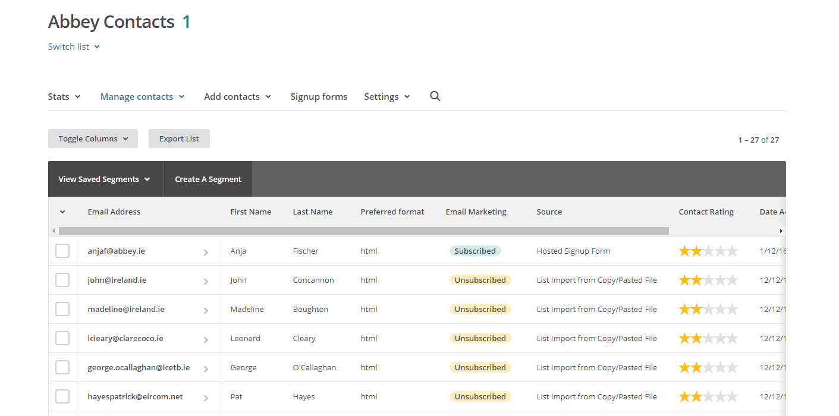

1. Select “embedded forms”

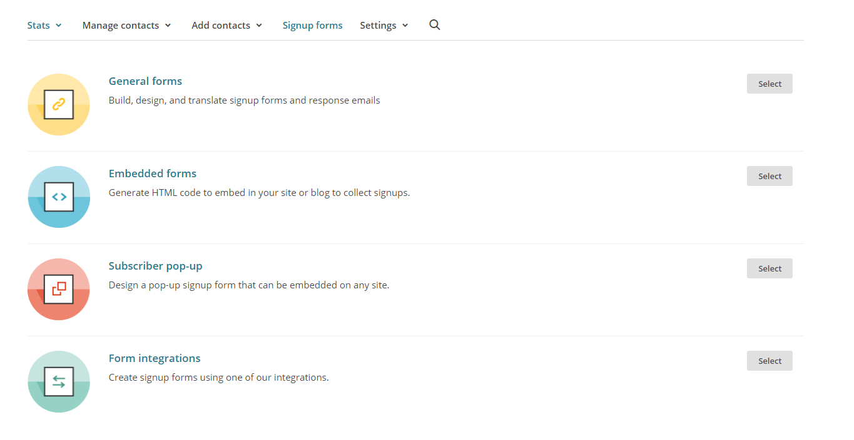

1. I generally use the classic form with only the options selected below.

You can make fields required if you like in the “form builder” (on the left side, small text in blue).

Edit in the “form builder”:

* The title (double click)
* Go to Field settings (on the right Hand side). There you can edit the text. Change the Conference name and E-Mail address)

1. Go to Settings. Select “Audience name and campaign default”. Here you need to change the Audience name, Default From name and Default from email address. Don’t forget to save.
2. Go to Settings again and select “Required email footer content”. The Company, Contact name and Email address need to be changed.
3. Once you’re happy with the form, copy the whole html link below.

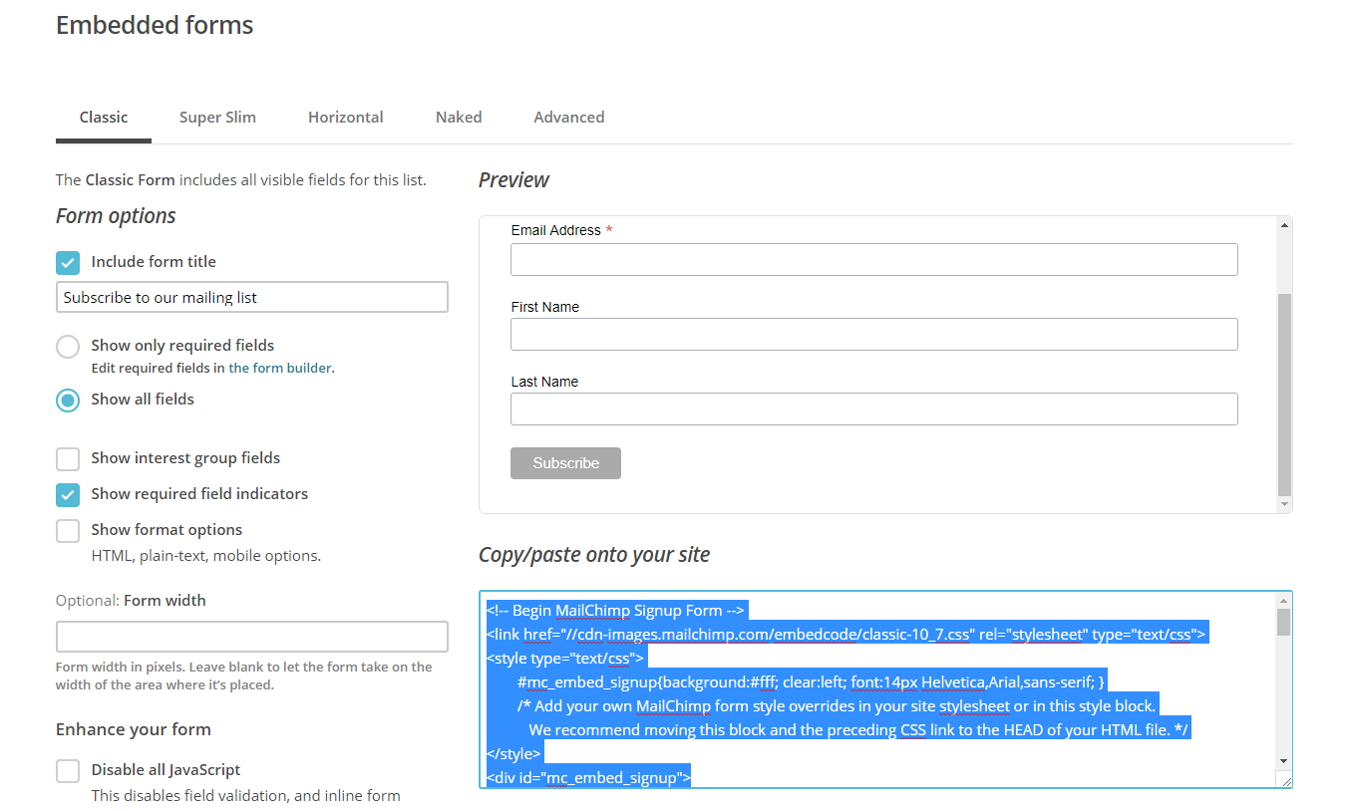

1. Open the website in the Wix editor and click on “add”, “more”, “html code”

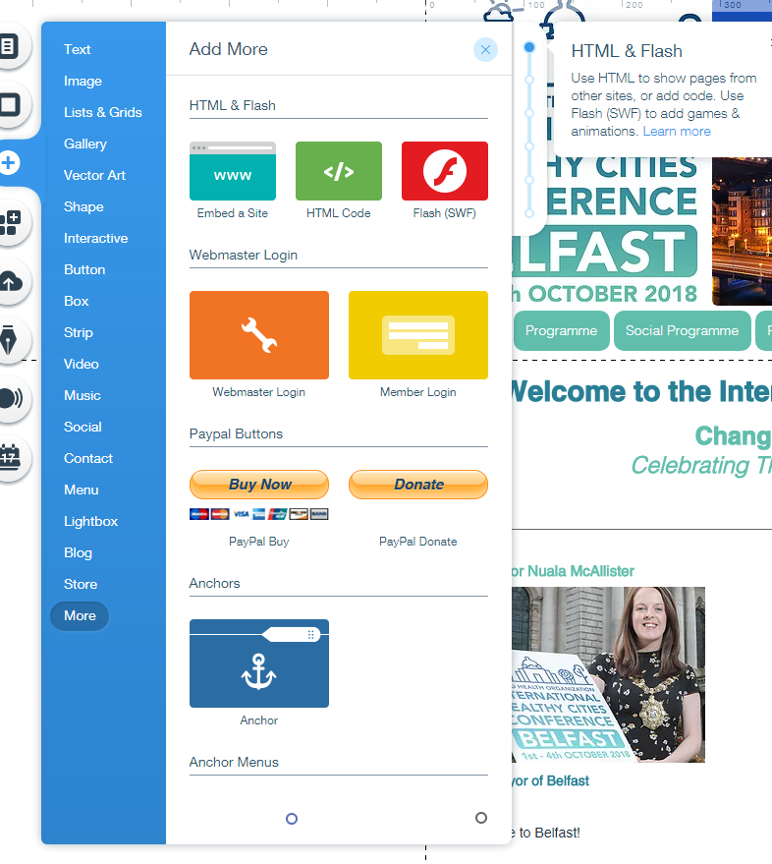

1. Click on “enter code”, select code and paste the code you copied from mailchimp in the fields.

1. Another way to add the “Subscribe Button” to Wix is to click on “add”, “button”, select one and click on the hyperlink symbol. Then select “Web Address”, “New window” and paste the URL (described below) into the field.

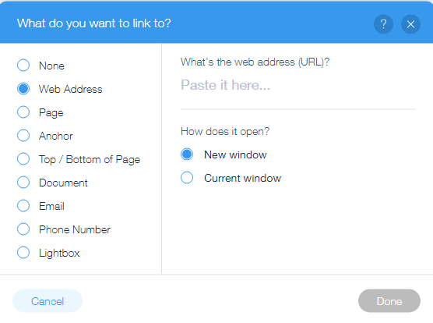

1. You can find the URL on Mailchimp, Embedded forms, ”signup forms”, “the form builder”, copy the “Signup from URL” and paste onto the wix website into the URL section.
2. To double check if the signup from is correct, add your details and then check if your details have been added to the mailchimp list.

**Mailchimp/Subscription form**

The button “Please subscribe here to receive further updates” can be found on almost on all websites.

In order to create the subscriber form you need to log in to Mailchimp:

Username: NicoRol  
Password: AbbeyConference20!8

1. Click on “Lists”
2. Replicate any list of the existing ones (arrow on the right side) and rename it to the conference for what you would like to create a new list/subscriber form
3. Click on the new list you created.
4. Click on “Settings” and on “List name and defaults”. Make sure all three options for the form settings have a small hook.

In “Campaign defaults” below, insert the name of the conference and year in “Default from name”. Insert the conferences email address below.

1. Click on “Settings” again and on “Required email footer content”.

Insert “Abbey Conference & Events” in Company and Contact gaps and the address details of Abbey  
Very important: At the very bottom please insert the website URL of the conference

Click save

1. Click on “Signup forms” (next to “Settings”) and click on “Form builder”
2. When you click on the arrow for “Signup form” you can choose between the different pages. Only the first forms are relevant that belong to “Subscribe”.  
   “Signup thank you page”: Insert the conference email address and hyperlink  
   “Opt-in confirmation email”: Insert the conference email address and hyperlink  
   “Confirmation thank you page”: Insert the conference webpage URL and hyperlink  
   “Final welcome email”: Insert the conference email address and hyperlink
3. Click on “Form builder” again and copy the hyperlink of the Signup form URL
4. Insert the link as a hyperlink to the button “Subscribe for updates” on the website via Wix (See No. 16).

# Surveymonkey

You can create a survey to send to all delegates after the conference took place

🡪surveymonkey.net User name: Abbey_tours PW:conference

🡪Create a copy by swiping over a conference name, click on “More Options” and click on “Make a copy”

🡪You can now create new questions and fields 🡪Save and send a test survey to your email address