# 1.Wix - Websites

Wix is the program we use to design our conference websites.

By clicking on the drop down menu on the top left you will be able to see all our websites.

By clicking on the image and then on “Manage site” you will see all the different settings.

Click “Select site” to open them in the web or “edit site” so you can make changes.

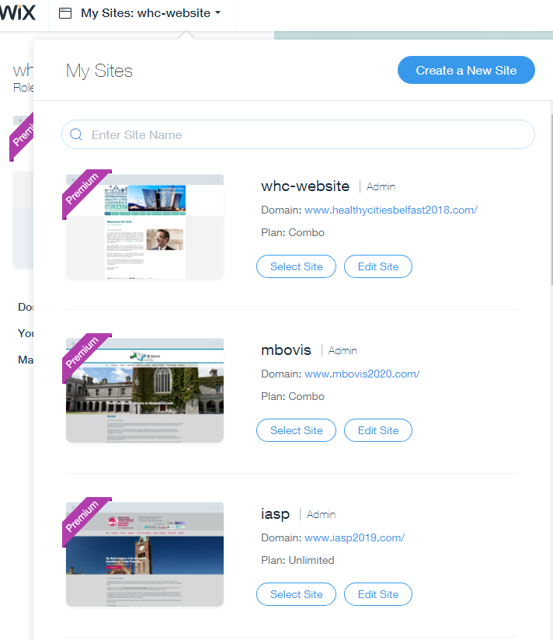

The most important buttons on the left are the following:

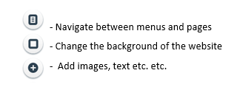

Always save your changes and publish them (when you have sign off -top right corner).

Once you finished making your changes in the editor, click on mobile view and make sure everything is shown correctly. You cannot make many changes in the mobile editor, but you can arrange the different objects.

When navigating in the menu you can add pages. In order to create a drop down menu on a page, click on the three dots and select subpage. Then drag it to wherever you want it. You can also hide pages ,so visitors cannot see them

# SEO and Google Analytics

**Step 1) Indicate how you want your website to appear on Google**

- Go to the Wix editor and “Manage pages”

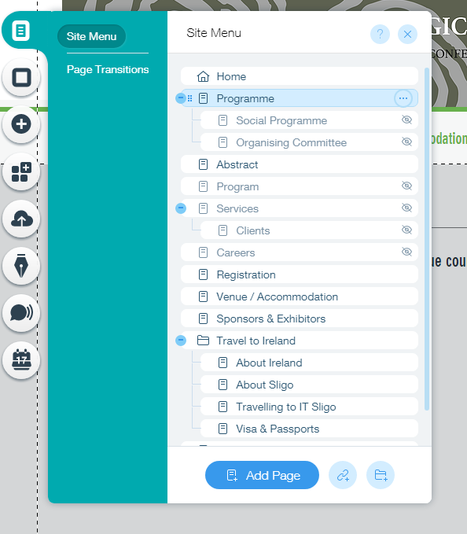

Click on the three dots and select Page SEO (SEO Google) 🡪 Then add Keywords, description, URL you want the site to appear on Google with.

Do this for each site.

**Step 2) Use Google Search Console to verify your website ownership**

<https://www.google.com/webmasters/verification/verification?hl=en&siteUrl=https://www.abbeyconference.ie/&continue=https://www.google.com/webmasters/tools/dashboard?hl%3Den%26authuser%3D0%26siteUrl%3Dhttps://www.abbeyconference.ie/%26sig%3DALjLGbMsEH9ljIoDtrPaJV_ZMzut_OD2OA&theme=wmt&authuser=0&priorities=vfile,vmeta,vdns,vanalytics,vtagmanager&tid=alternate>

Easiest method via HTML tag (Under „Alternate Methods”)

🡪 Add the Meta tag given to the website (Site Settings, SEO, click on add header code Meta tags

🡪 Once published click “verify” at the search console

Make sure you always “allow search engines to include your site in search results”! (See below)

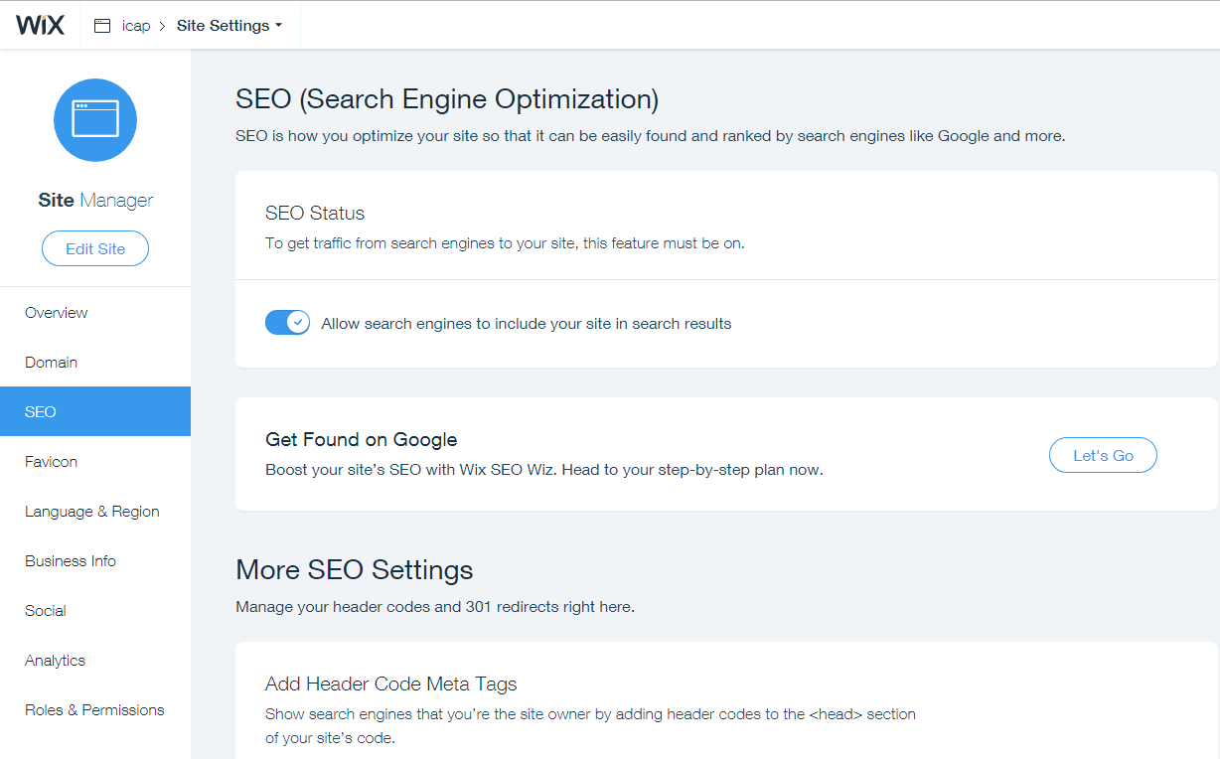

Step 2) Go to the Search Console Crawler (<https://www.google.com/webmasters/tools/submit-url?hl=en&mesd=AB9YKzIUeCFnRyCsS1trlzqpIuyVlvwbxrlQr4YkfOd9c8vyQEbHcDnErdg9unzYX1cHKzgDhXgmNCRw0XrV6PGX_L3i5VSj5vZqo-izbx_mosZ9Ml7rI6PxL8M0DtniM5ESzTBa3R6H&pli=1>)

Enter the Websites URL, this way Google is actively going to search for it.

Any time the description/title is updated the URL should be inserted to the Crawler, this way it is updated faster on Google!

Associate your property with Google Analytics

If you associate a Google Analytics property with a site in your Search Console account, you’ll be able to see Search Console data in your Google Analytics reports. To associate your property you have to verify your ownership first, as explained above.

You can do this via this link: <https://www.google.com/webmasters/tools/analytics-property-selection?utm_medium=incoming-link&utm_campaign=HelpCenter>

**Step 3) Google Analytics**: <https://analytics.google.com/analytics/web/#embed/report-home/a112284000w167372190p167622364/>

Enter Google Analytics and click on Admin (See below)

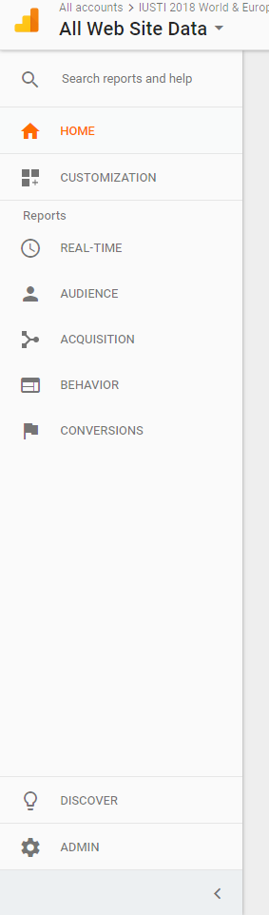

Then Select the Property drop down menu and click “Create new property”

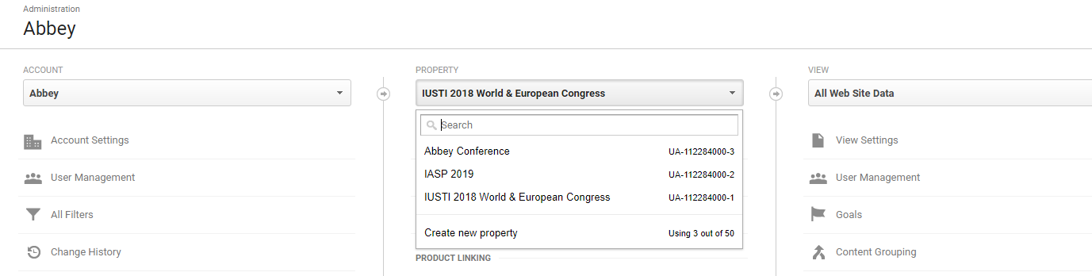

- Enter the details and get the Tracking ID

- Send the ID and the Website’s name to Amy, only she as the website owner can then use the ID to set up Google Analytics in Wix

- If you then select “All website data” for a site, you will be able to see all statistics

**Apply a Filter**

In order to exclude clicks from within Abbey, you can apply a filter (Under “All Website Data”). Exclude all IP Adresses that are equal to:

* 89.204.241.32
* 89.204.241.33
* 89.204.241.34
* 89.204.241.35
* 89.204.241.36
* 89.204.241.37
* 89.204.241.38
* 89.204.241.39
* 89.101.237.240
* 89.101.237.241
* 89.101.237.242
* 89.101.237.243
* 89.101.237.244
* 89.101.237.245
* 89.101.237.246
* 89.101.237.247

**Sitemap**

A Sitemap is a list of pages on a website that is accessible to all users. An XML sitemap is a way for website owners to tell search engines about all the pages that exist on their website. While sitemaps do not boost your search rankings, it allows search engines to better crawl your website.

How to add a sitemap to your website:

Enter Google Search Console and select a website. In the dropdown menu “crawl” select “sitemaps”. In the top right corner select “add/test sitemap”.

Add sitemap.xml which contains link to your other sitemaps. You can either submit sitemap_index.xml alone or submit all other sitemaps one by one. By submitting sitemap_index.xml alone, Google will automatically discover other sitemaps and crawl them.

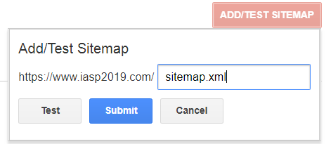

**More detailed approach for SEO Google:**

**SEO Google**

If you would like your conference website to appear higher in the google searches you need to connect the website with google:

1. Login to wix and choose a website. Please click on “settings” and then on “click found on google”  
   Username: [greg@abbey.ie](mailto:greg@abbey.ie)  
   Password: abbeyconference
2. Goal is to achieve as much small green hooks as possible.
3. The boxes with the exclamation marks need to be updated. Click and them and click on “Go to Editor” to make the change.
4. After you have done your change, make sure to click on refresh next to the “Go to Editor” button

Sometimes you can’t update everything, e.g. (add social links: because not all organizations have twitter, facebook, etc..)

1. Most important are the SEO title, the keywords, the page URL, and description of each pages on the website  
   Click on the three dots next to the pages on the menu.  
   Then click on “SEO & Social”.  
   There you can add description on the page (same description for all pages – date, location, name of event)  
   Enter the keywords: name of event, year, location, etc  
   Also make sure to create a title that differentiates from other titles on other websites  
   A lot of times it happens that you just copy the page from another to create a new one. Then it happens that the URL is “copy of …”. Please change it, as well as the title! Always make sure to update the SEO when you add a new page.

When you make changes, it will not immediately be shown on the internet as it needs time to connect to google.