

Processing a refund by bank transfer

1. In internet explorer : Shared staff docs > accounts doc > refund authorisation form

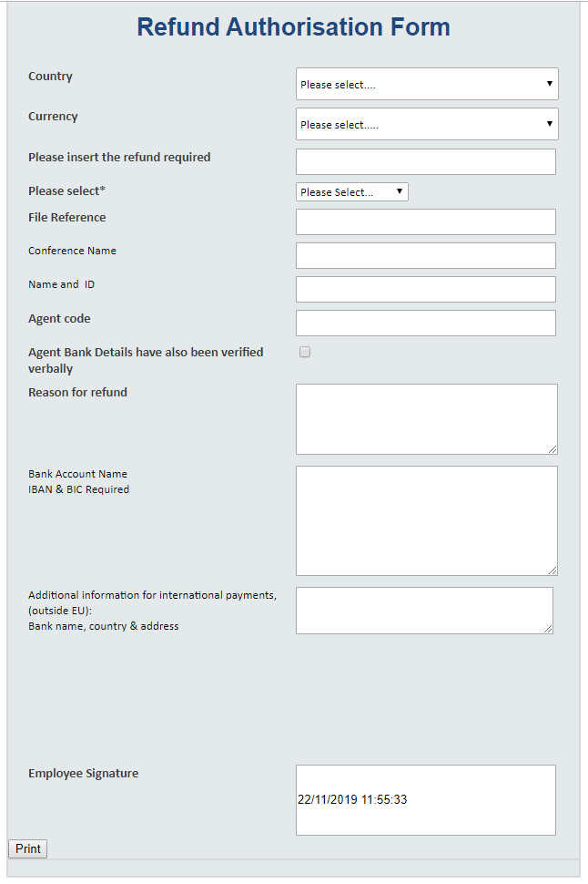

**Country-** TP Ireland

**Currency** - €/£ select the currency that the conference is taking place in

**Refund required** – insert amount to be refunded

Check the relevant box

**Please select*-** use the drop down the to indicate the value of the refund,

**File ref** : This is a specific file ref for each conference and can be located in the last tab in the RB ( receipt book)

**Agent code** – Same as above

**Conference Name** – eg Agile lean ( must match the file ref & agent code)

**Name and ID** –include the Events Air ID with the delelgates name

**Reason for refund** – Brief description eg accommodation cancelation or reg cancelation etc

**Bank Detail** –Customer name ,Bank name ,bank address ( if possible) IBAN BIC Sort CODE

**Signature**- Sign off from an appropriate manager depending on the amount of the refund

3.Print document

4.Sign and scan .

5.Email Daniel in Finance – [danield@abbey.ie](mailto:danield@abbey.ie)

6.Rename doc with Conference name and ID number and save in N:\Conference & Events\Financials\Bank Transfers 2019\D.S Bank transfer refunds sent